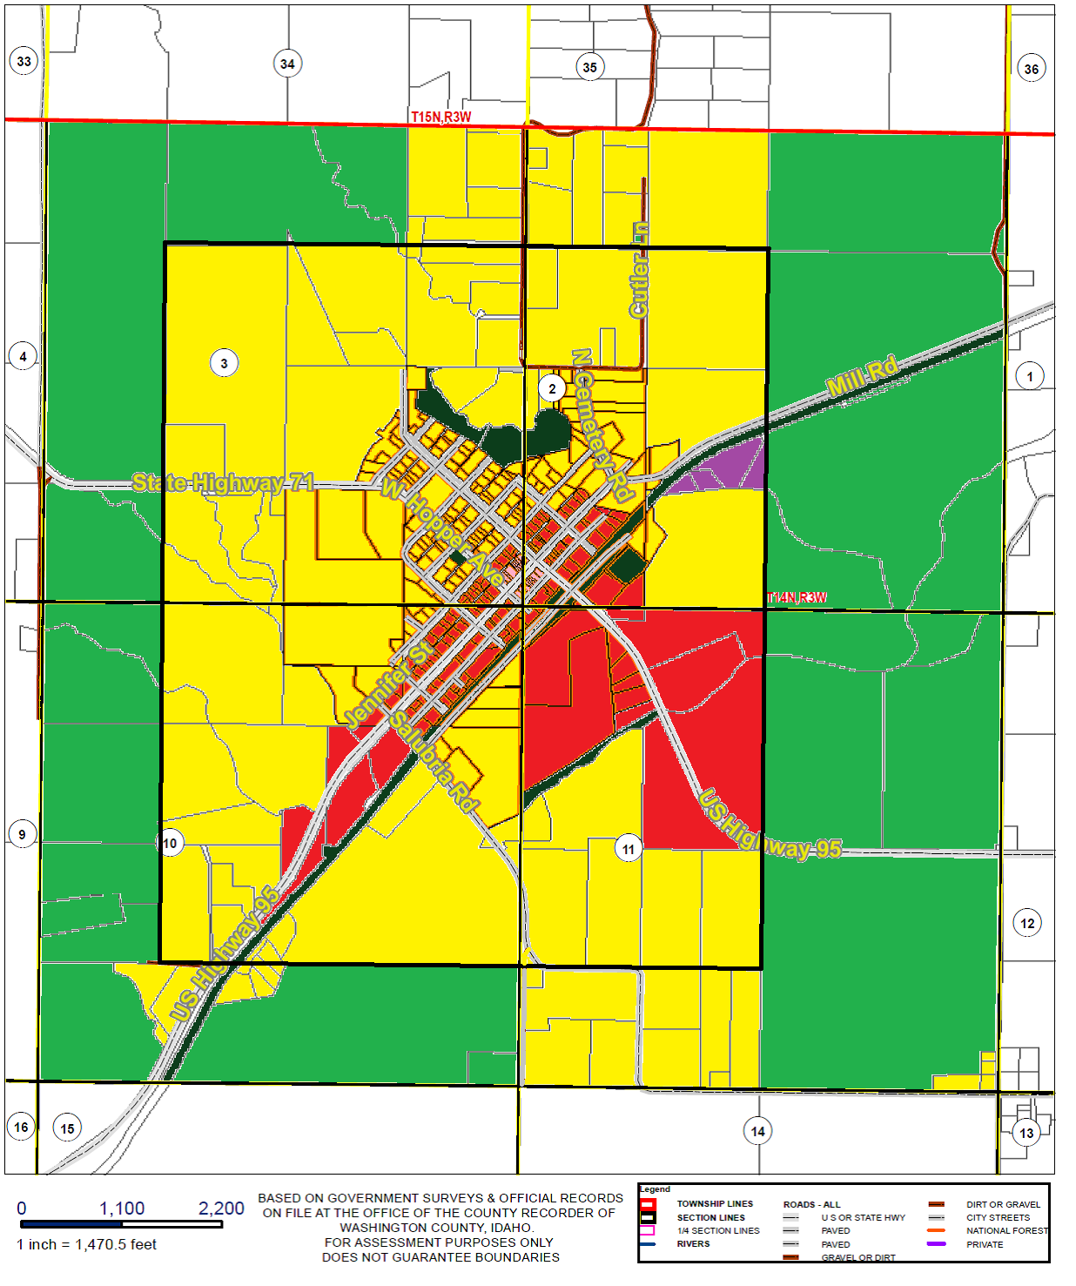

Residential Agricultural Central Business District Commercial

Commercial Industrial Open Space and Recreation