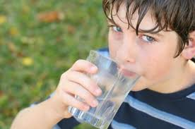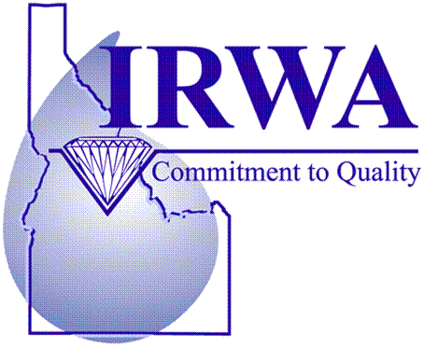

*Our constant goal is to provide you with a clean and dependable supply of drinking water. Cambridge’s Water Department continuously strives to ensure that your drinking water looks, smells and tastes great. We want you to understand the efforts made to protect our water resource, which is the heart of our community, our way of life, and our children’s future.*

City of Cambridge

Annual Water Quality Report for Calendar Year 2016

Date of Distribution: June 2017

https://icspediatriaaltpenedes.files.wordpress.com/2013/11/nen-aigua.png

City of Cambridge PWS# 3440002

P.O. Box 220

Cambridge, ID 83610

Public Works Supt.: Ernie Houghton (208) 257-3318

Population Served: 328 Number of Connections: 242

Water Sources: Well #1 (Emergency well; Active); Well #2 (Primary well; Active); Well #3 (Inactive)

**W**e are happy to report that our drinking water meets or exceeds federal and state requirements. This report has been designed to inform you about the quality of the drinking water and services we deliver to you and your family every day. Because of our wonderful groundwater quality, the water department had to conduct tests for only three contaminants last year.

**S**ources of drinking water (both tap and bottled water) include rivers, lakes, streams, ponds, reservoirs, springs, and wells. As water travels over the surface of the land or through the ground it dissolves naturally-occurring minerals and, in some cases, radioactive material, and can pick up substances resulting from the presence of animals or from human activity. Contaminants that may be present in source water include:

* **Microbial contaminants**, such as viruses and bacteria, which may come from sewage treatment plants, septic systems, agricultural livestock operations, and wildlife.
* **Inorganic contaminants**, such as salts and metals, which can be naturally-occurring or result from urban storm water runoff, industrial or domestic wastewater discharges, oil and gas production, mining, or farming.
* **Pesticides and herbicides**, which may come from a variety of sources such as agriculture, urban storm water runoff, and residential uses.
* **Organic chemical contaminants**, including synthetic and volatile organic chemicals, which are by-products of industrial processes and petroleum production, and can also come from gas stations, urban storm water runoff, and septic systems.
* **Radioactive contaminants**, which can be naturally-occurring or be the result of oil and gas production and mining activities.

**Drinking water, including bottled water**, may reasonably be expected to contain at least small amounts of some contaminants. The presence of contaminants does not necessarily indicate that water poses a health risk. More information about contaminants and potential health effects can be obtained by calling EPA’s Safe Drinking Water Hotline at 1-800-426-4791 or at its website, <http://www.epa.gov/safewater/hotline/>.

**In order to ensure that tap water is safe to drink**, EPA prescribes regulations which limit the amount of certain contaminants in water provided by public water systems. Food and Drug Administration regulations establish limits for contaminants in bottled water which must provide the same protection for public health.

**Cambridge has a Source Water Protection Plan** that is recognized and certified by Idaho Department of Environmental Quality (DEQ). This plan was designed to protect the integrity of our drinking water and the sources from which it comes. It identifies potential contaminant sources and land practices that pose the greatest risks to our drinking water, and measures undertaken to protect all members of our community. A copy of this plan is available for review at Cambridge City Hall.

The Protection Plan needs to be updated, and the City of Cambridge is seeking the participation of city residents and business owners. If you are interested in participating or would like to provide comment, please contact our office at 208-257-3318, or the Idaho Rural Water Association at 208-343-7001 for additional information.

Community water supplies are continuously jeopardized by cross-connections unless appropriate valves, known as backflow prevention devices, are installed and maintained. Idaho *State Rules for Drinking Water Systems* states “*There shall be no connection between the distribution system and any pipes, pumps, hydrants, water-loading stations, or tanks whereby unsafe water or other contaminating materials may be discharged or drawn into a public water system.”*(IDAPA 58.01.08). For that reason, all residences using sprinkler systems for landscape irrigation are required to have backflow prevention devices installed and inspected every year. Failure to comply will result in your water being turned off. Please contact our office at 631-1557 for additional information.

Monitoring Waiver Information: The U.S. Environmental Protection Agency (EPA) has granted the state of Idaho authority to issue monitoring waivers for inorganic compounds (IOCs), volatile organic compounds (VOCs) and synthetic organic compounds (SOCs). Because of our excellent water quality, Cambridge currently has monitoring waivers for IOCs, VOCs, SOCs and radioactive compounds, thus allowing the city to sample and test less frequently and saving you money.****

The City of Cambridge invites all residents to attend its public meeting where topics concerning matters related to water, water projects, and other important issues may be discussed.

Regularly scheduled meetings are held on the

SECOND MONDAY of each month @ 7:00pm.

It’s finally here!

**WHAT IS IN MY WATER?**

The City of Cambridge routinely monitors for contaminants in your drinking water in accordance with federal and Idaho state regulations. The following table shows the detection of the following constituents in your water for the period of January 1st through December 31st, 2016. The following table provides information on your water quality.

|  |  |  |  |  |  |  |  |
| --- | --- | --- | --- | --- | --- | --- | --- |
| **CONSTITUENT TABLE** | | | | | | | |
| **Constituent** | **Violation**  **(Yes/No)** | **MCL** | **MCLG** | **Lowest**  **Level**  **Detected** | **Highest**  **Level**  **Detected** | **Date**  **Tested**  **(mm/yyyy)** | **Typical Sources of Contamination** |
| **INORGANIC CONTAMINANTS** | | | | | | | |
| Arsenic (mg/L) | No | 10.00 | 0 | 0.019 | 0.019 | 06/2015 | Erosion of natural deposits; water  additive which promotes strong  teeth; discharge from fertilizer  and aluminum factories. |
| Fluoride (mg/L) | No | 4 | 4 | 0.370 | 0.370 | 03/2012 | Erosion of natural deposits; water  additive which promotes strong teeth. |
| Nitrate (mg/L) | No | 10 | 10 | 0 | 0.00 | 03/2012 | Runoff from fertilizer use; sewage;  leaching from septic tanks; erosion of natural deposits. |
| Nitrite (mg/L) | No | 1 | 1 | 0.03 | 0.03 | 03/2012 | Runoff from fertilizer use; sewage;  leaching from septic tanks; erosion of natural deposits. |
| Sodium (mg/L) | No | N/A | N/A | 60.1 | 60.1 | 07/2016 | Erosion of natural deposits. |
| **DISINFECTION BY-PRODUCTS** | | | | | | | |
| HAA5 Haloacetic Acid (ppb) | No | 60 | 60 | 0.000 | 0.000 | 07/2014 | By-product of drinking water  disinfection. |
| TTHMs Total Trihalomethane | No | 100 | 80 | 0.000 | 0.000 | 07/2014 | By-product of drinking water  disinfection. |
| **MICROBIAL CONTAMINANTS** | | | | | | | |
| Coliform (TCM) | No | 1 | 0 | 0 | 0 | Monthly | Naturally present in the environment. |
| **RADIOACTIVE COMPOUNDS** | | | | | | | |
| Gross Beta Particle Activity (pCi/L) | No | **50 | 0 | 2.79 | 2.79 | 01/2009 | Decay from natural and man-made deposits. |
| **LEAD/COPPER** | | | | | | | |
| **Constituent** | **Violation (Yes/No)** | **MCLG** | **Action Level** | **Lowest**  **Level Detected** | **Highest**  **Level Detected** | **Date**  **Tested**  **(mm/yyyy)** | **Possible Source of Contamination** |
| Lead (ppb) | No | 0 | 15 | 0 | 0 | 06/2015 | Corrosion of household plumbing  systems; erosion of natural deposits. |
| Copper (ppm) | No | 1.3 | 1.3 | 0.15 | 0.15 | 06/2015 | Corrosion of household plumbing  systems; erosion of natural deposits. |

**DEFINITIONS**

In the table above, you will find terms and abbreviations you might not be familiar with. To help you better understand these terms we’ve provided the following definitions:

***Action Level***: The concentration of a contaminant, which, if exceeded, triggers treatment or other requirements, which a water system must follow.

***Maximum Contaminant Level (MCL)***: The highest level of a contaminant that is allowed in drinking water. MCLs are set as close to the MCLGs as feasible using the best available treatment technology.

***Maximum Contaminant Level Goal (MCLG)***: The level of a contaminant in drinking water below which there is no known or expected risk to health. MCLGs allow for a margin of safety.

***Maximum Residual Disinfectant Level (MRDL)***: The highest level of a disinfectant allowed in drinking water. There is convincing evidence that addition of a disinfectant is necessary for control of microbial contaminants.

***Milligrams per Liter (mg/L):***

***Non-Detect (ND)***: Laboratory analysis indicates that the constituent is not present.

***Parts per million (ppm)***: One part per million corresponds to one minute in two years or one penny in $10,000.

***Parts per billion (ppb)***: One part per billion corresponds to one minute in 2,000 years or one penny in $10,000,000.

***Picocuries per liter (pCi/L):*** The measure of radioactivity.

***Treatment Technique***: A required process intended to reduce the level of a contaminant in drinking water.

**Copper Informational Statement** (Health effects and ways to reduce exposure). Copper is an essential nutrient, but some people who drink water containing copper in excess of the action level over a relatively short amount of time could experience gastrointestinal distress. Some people who drink water containing copper in excess of the action level over many years could suffer liver or kidney damage. People with Wilson’s Disease should consult their personal doctor. If you are concerned about copper in your drinking water, you may wish to have your water tested. Information on copper in drinking water, testing methods, and steps you can take to minimize exposure is available from the Safe Drinking Water Hotline at 1-800-426-4791 or at <http://www.epa.gov/safewater/lead>.

**Some people may be more vulnerable to contaminants** in drinking water than the general population. Immune-compromised persons such as persons with cancer undergoing chemotherapy, persons who have undergone organ transplants, people with HIV/AIDS or other immune system disorders, some elderly, and infants can be particularly at risk from infections. These people should seek advice about drinking water from their health care providers. EPA/Centers for Disease Control and Prevention (CDC) guidelines on appropriate means to lessen the risk of infection by *Cryptosporidium* and other microbial contaminants are available from the Safe Drinking Water Hotline at 1-800-426-4791 or at http://www.epa.gov/safewater/hotline/.

Many Americans take drinking their water for granted, but world-wide, people face tremendous challenges and obstacles in getting clean drinking water for their family and themselves. Women in undeveloped countries must walk an average of 3.7 miles to get water; in war-torn areas, water may not even be available.

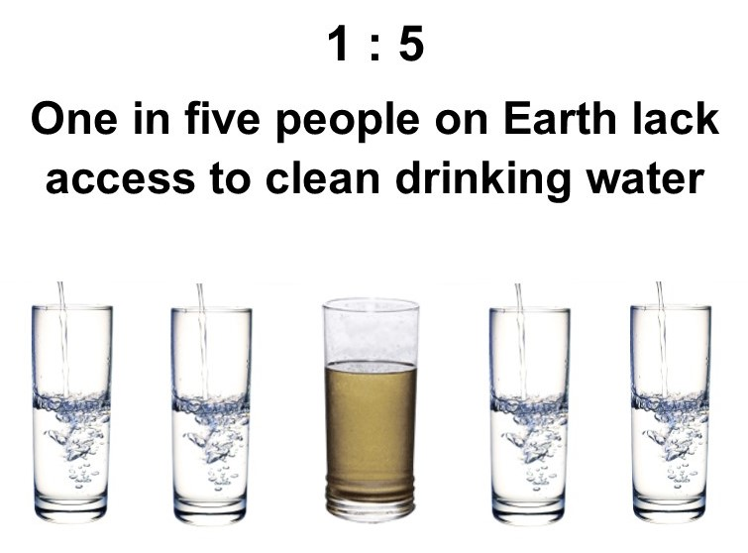

kiddrinkingwaterkiddrinkingwaterkiddrinkingwaterkiddrinkingwater

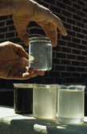

Par Estates invites all property owners to attend our quarterly public meetings where topics concerning matters related to water, water projects, and other important issues may be discussed. Our regularly scheduled meetings are ________